Success: Full Living
A Course in Spirituality & Meditation
by Friar Justin, OFM

• Setting Goals • Finding Purpose • Achieving Happiness

Important: This is the new date for the program
Saturday & Sunday, October 10th and 11th 2020
Indianapolis

o you want to experience more peace
D
and less stress? Do you want more out
of life? Would you like more balance
in your daily schedule? Here is a weekend experience that can help you attain this and
any other goals you desire.
Class Location:
The Hermitage (3650 E. 46th St.)

Workshop Date & times:
Saturday, Oct., 10th - 9 a.m. - 5 p.m.
Sunday, Oct., 11th - 9 a.m. – 5 p.m.
Prepaid: $150.00 (at the door 175.00)

Limited Seating due to social distancing
Please register by Tuesday, October 6th 2020

In Success: Full Living, you will learn how to:

- Set personal goals and learn how to achieve them
- Keep your attitude positive
- Motivate yourself
- Overcome fear
- Move through life changes successfully
- Affirm yourself and others
- See problems as opportunities
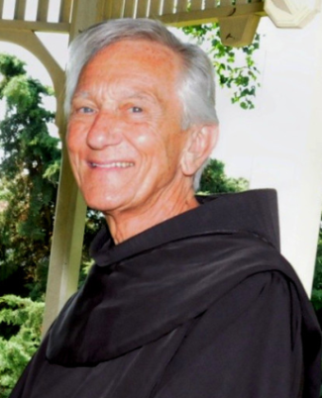
Personal Note from Fr. Justin
Dear Friend:
I have taught Success: Full Living all over the world. What a thrill it is to see individuals of every age, religion, culture, and occupation find their way to more peaceful, more productive, more satisfying lives!
Success in life is really a simple process, even though our technological world has tried to make us think other-wise. The essentials are:
Choose appropriate goals and
Develop positive attitudes.
Everything else happens automatically.
This workshop, based on my book, Success: Full Living explains the Life Mechanism and how it works. If you make one set of choices, you will create a satisfying life. If you make another set of choices, you will create a dissatisfying life. The choice is always yours.
During the weekend, you will be able to complete a detailed self-evaluation, set goals in
7 major areas of your life, and learn to develop positive attitudes and much more.

God bless!

Success: Full Living

Learn about The Life Mechanism which works for you every day.

Location: The Hermitage
3650 E. 46th Street
(317) 545-0742

New Class Date and Times:

Saturday, Oct., 10th 2020
9:00 a.m. – 5:00 p.m.
Sunday, Oct., 11th 2020
9:00 a.m. – 5:00 p.m.

Limited seating due to Social Distancing
To register, complete the form below or
phone (317) 545-0742 or email: lulugk@att.net. after 1:30 p.m.
New Students: A $50.00 deposit must be received on or by Tuesday, Oct., 6th to ensure your discount and reserve your seat.

Once you have taken the SFL class you will be able
to retake the class, any time it is offered, for a small
donation of $25.00.

Class Registration

Prepaid: $ 150.00
List Price: $ 175.00

Additional Family Member(s) $125.

Fee includes your Manual, Certificate, ID Card
and a copy of the Success: Full Living book.
plus coffee, tea, water, and snacks at 8:30 a.m.

Please make checks payable to The Hermitage and mail to the address below.
To pay using your credit card call LuLu at 317-545-0742 (after 1:30 p.m. Monday thru Friday).
For more information email LuLu at
lulugk@att.net or call 31-545-0742.

Graduate must register
A graduate donation of $25 is appreciated to help cover class costs.

The Hermitage c/o LuLu
3650 E. 46th Street
Indianapolis, IN 46205
317 549-0742

Name: ______________________________________________________________________________
Address: _____________________________City_________________ State _____Zip _____________
Phone: ____________________________ Amount Enclosed $ ____________Check #_____________
Email:_______________________________________ New Student ___________ Grad.__________

