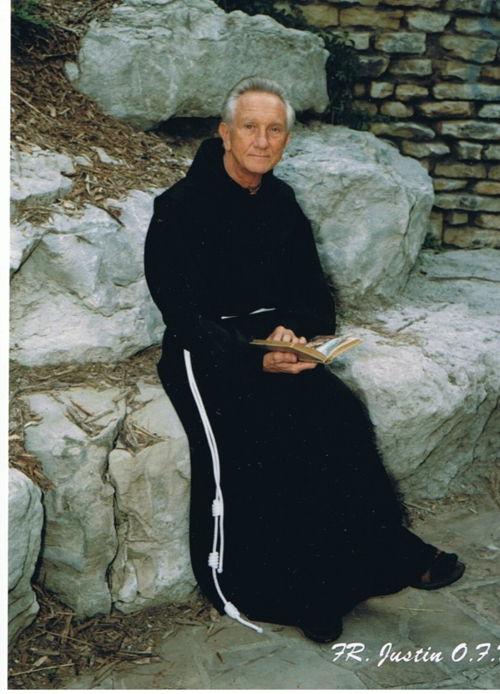
Living the Prayer of Quiet
Passive Meditation
Harmony is the world within – world of thought and feeling and power, of light and life and beauty; although invisible, its forces are mighty. The Source of all power is the world within and the Universal Mind of which we are the image and likeness.

A New One-day Workshop
The Hermitage
3650 East 46th St. Indianapolis, IN 46205

Date: Saturday, September 12, 2020
Time: 9:00 AM– 6:00 PM

Passive Meditation is a prayer in which you can experience Oneness with God, Universal Cosmic Energy, or whatever else you want to call the Source Energy of the Universe. This kind of prayer is expressed in forms like Zen, Transcendental Meditation, and Yoga, but in the Christian tradition it is referred to as the Prayer of Quiet. In this kind of Meditation, you become a passive agent and allow God to take over. You can become aware of goals for your future as well as solutions to personal problems AND you can experience being One with Love, Beauty, Joy, Peace and Harmony.

This is a workshop that combines theory and practice. Although this Workshop has been offered many times by Friar Justin at Peace Be Steal in Perth Australia, this will be the first time it has been offered at The Hermitage.

Workshop Fee: $75; Please reserve your place by Monday, September 7. Send your check to:
The Hermitage 3650 E. 46th Street, Indianapolis IN 46205
or to pay using your credit card, call LuLu at 317-545-0742 (after 1:30 p.m.)

Name _____________________________________________________________________________________

Address: __________________________________City________________ State___________Zip___________

Phone: ___________________________________Email:____________________________________________

Paid: _________________

IMPORTANT:
We ask that all participants bring their lunch so that we do not have to break the silence by going out for food. (We will have water, coffee and tea available.)

