Silva Intuition System:

This program is open ONLY to graduates of the Basic Lecture Series and those who have completed the Silva Life System Program.

Class Begins on Friday Evening:
August 16, 2019 - 7:00 - 10:00 PM
Class Continues:
Saturday, Aug. 17 - 9 AM to 6 PM
Sunday, Aug. 18 - 9 AM to 6 PM

PLEASE NOTE: All registrations must be
made by Aug., 12 with a $100 deposit, to receive a discount and secure your seat.

Graduates
If you are a Graduate of the Silva Intuition Class,
or the BLS class, you can retake SIS class for a donation of $30.00.
TO REGISTER YOU MUST PRESENT YOUR
ID NUMBER.

To register, complete the form below, OR CALL LuLu at (317) 545-0742 or email: lulugk@att.net

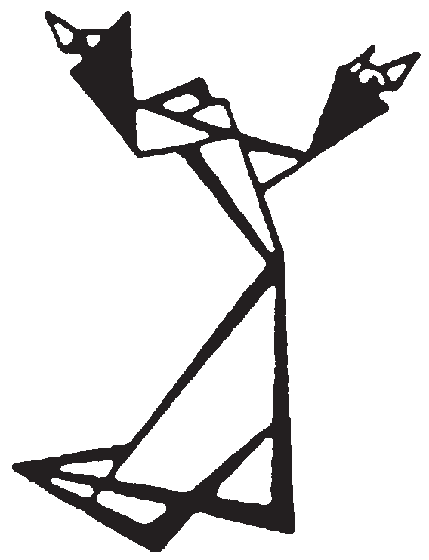
The Hermitage
Attn: LuLu
3650 E. 46th Street
Indianapolis, IN 46205
(317) 545-0742
Email: lulugk@att.net
Name Address City State Zip_______
Phone(s)
Amount Enclosed Check number _ _
MC/VISA# __ Exp. Date E-mail
Graduate Donation___________________

*Additional family member price applies to spouse and dependent
children, 18 or younger. This price also applies to full-time students (ID required), and senior citizens (60 and older).

Graduates: ID # _________________

Year you took the class ___________

MEDITATION PROGRAM Silva Intuition System INDIANAPOLIS

Class Registration

INVESTMENT
At the door $425

Additional family member(s) *$375

Prepaid $375

Additional family member(s) *$325

*A $100 deposit (for NEW STUDENTS) to register for the class must be received by August 12th 2019.
Please make checks payable to The Hermitage and mail to: 3650 E. 46th Street, Indianapolis, IN 46205. You can register by phone by contacting LuLu at (317)545-0742
or email me at: lulugk@att.net.
.

Silva Intuition System:
INDIANAPOLIS
A Graduate Meditation Program

Unlock the Power of your Mind

Class Begins on Friday evening August 16, 2019 - 7:00-10:00 PM
Class Continues:
Saturday & Sunday, August 17 & 18, 2019 9:00 a.m. - 6:00 p.m.

Important Notice
The Basic Lecture Series is now two separate programs. The first two days is the
Silva Life System. The second part of the program, which is one night and two days,
is now a graduate program under the title Silva Intuition System.

Please Note:
If you took the Silva Life System class in June 8 & 9, 2019 and register for the Silva Intuition
System class, and pay a deposit of $100.00 you will receive this class for $325.00 instead of $375.

Only graduates of Basic Lecture Series (“BLS”) and/or the Silva Life System (“SLS”) can be admitted to
this program.
(Participants must know how to enter level and be familiar with the techniques taught in the BLS and the SLS.)

For graduates of the Basic Lecture Series, the Silva Intuition System is a revision of what had been in the BLS. However, the revised program (SIS) has additions that include psychometry, the mental video technique, the theory and practice of remote viewing, etc.

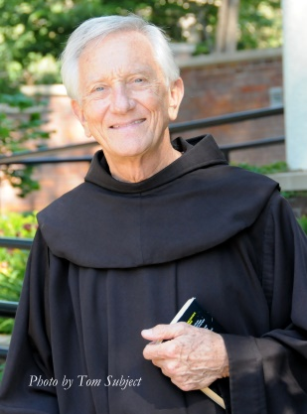
The Silva Intuition System will help you use the God Presence within to consciously connect with all of creation: inanimate matter, plant life, animal life, and human life. You will be taught how to gather information to clarify personal goals, to heal yourself and others, to build successful relationships, to attract what you need in every area of your life, and much more.

You must register by August 12, 2019 to give us time for us to order your Manual and Certificate.

Unlock the Power of your Mind with Silva Instructor Friar Justin
